Friday, February 24, 2006
NORMAN BULLETIN 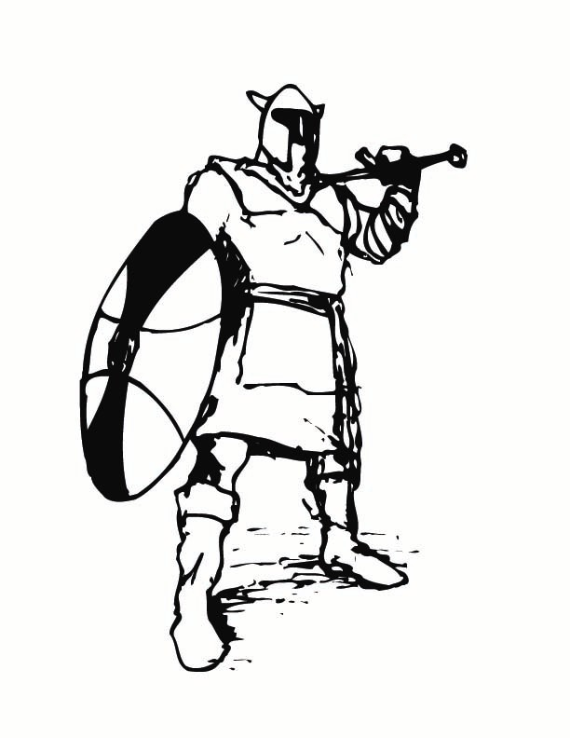
Published 3 times a week - Monday, Wednesday, Friday
“ He who refuses to embrace a unique opportunity loses the prize
as surely as if he had tried and failed….”
~William James

SCHEDULE FOR THE WEEK
Today Regular Schedule
Monday Regular Schedule Staff Meeting 3:00 Room 300
Tuesday Regular Schedule
Wednesday Block Schedule
Thursday Block Schedule SEC Meeting 1:15 p.m. / BHEA Executive Board Meeting 3:45 p.m.

STAFF
THE LIBRARY’S MAGAZINE DISTRIBUTION of past issues has begun! Please return your request sheets, circling the titles you’d like. Forms are available at the sign-in bulletin board.

SENIORS
SENIOR EDITION – If you would like to be in the 2006 Senior Edition of Highlights, please submit Senior Polls by March 3, 2006 and Senior Farewell’s and Baby Pictures by March 17, 2006, to room 253. Additional copies of the polls are also available in room 253.
SENIOR TEA MODEL & HOST APPLICATIONS will be available on Wednesday, March 1, in all Houses. Please be sure to pick up an application, fill in all needed information and return your application to House C by Wednesday March 15, 2006
SMC Counselor will be on campus Tuesday, February 28, in the Career Center, room 292 @ 9:30 a.m.
MEN! By registering for the Selective Service System, you satisfy a legal obligation, protect your eligibility for student financial aid, job training, government employment, and for immigrants, U.S. Citizenship. The easiest way for 17 and 18 year-old men to register and comply with the law is to register via the Selective Service System’s web site www.sss.gov

SENIORS & JUNIORS
DO YOU HAVE A LEAST ONE ANCESTOR WHO EMIGRATED FROM ITALY? Are you interested in a Leadership/Government all-expenses paid Workshop to Washington D.C? Get more info at www.niaf.org/s21/2006

ALL STUDENTS
HURRICANE KATRINA VICTIM’S FUNDRAISER Mrs. Fine’s Latin Class is fundraising for Hurricane Katrina victims at Belle Chasse High School in Louisiana, Today is the last day to donate books, art supplies, toys, sports equipment and cash to help make student life a bit better. Drop off donations to room 212 periods 2-5.
DO YOU HAVE NEW OR USED BOOKS YOU WANT TO GIVE AWAY? Members of Mrs. Fine’s Latin Class want your books for Hurricane Katrina victims at Belle Chasse High School in Louisiana. Students will visit your 2nd period classes Today.
APPLICATIONS FOR HONORS/AP Studio Art are available in Room 262 from Mr. Federman, Interviews, applications, and portfolio submissions have begun; pick up the application Now and sign up for an interview date. The Board portfolio types are 2D Design, Drawing, and 3D Design. Don’t miss your opportunity… class space is limited!
CALLING ALL POETS, ARTISTS, DANCERS, singers, musicians, and lovers of Spanish language and culture. Come to room 250 at lunch Today to sign up for auditions for Fiesta “Celebremos”. Meet the distinguished panel of international judges!
WINTER WONDERLAND volunteers needed for Sunday, February 26, from 9:00 – 2:30 p.m. at Roxbury Park. Sign-up in room 301.
AP EUROPEAN HISTORY, AP US HISTORY & AP GOVERNMENT/HONORS ECONOMICS applications will be available beginning Monday, February 27 from the Social Studies teachers. All completed applications must be turned in by Friday, March 10. Entrance tests for qualified applicants will be given on Wednesday, March 16, after school.
CONCERNED YOU OR A FRIEND MAY HAVE A DRUG OR ALCOHOL PROBLEM? Compulsive behavior? If so, please attend the Sober Lunch Meeting in room 521 Monday, February 27. Everything said at the meeting is confidential. For more information, please see Dr. Wolfe in room 292.

NEED HELP IN A SUBJECT? Come to room 234 on Mondays and Tuesdays… Bring your lunch and get help!
HELP A CHILD IN AFRICA learn to read. Donate new and used books, encyclopedias, dictionaries, and magazines by Tuesday, February 28. Boxes will be placed in the library, all houses, and the attendance office. CHANGE THE WORLD…one book at a time!
HAVE YOU PRE-PAID FOR A 05-06 AGENDA? If so, please come to the student store at lunch and pick-up your copy prior to the Wednesday, March 1st deadline.
YEARBOOK PRICES will go up to $105.00 on Wednesday, March 1st, so buy your yearbook now…the current price is $95.00. Yearbooks may be purchased from Mrs. Joseph in room 251. Buy one before the price goes up!
STUDENTS INTERESTED IN QUALIFYING FOR HONORS OR AP ENGLISH for the 2006-2007 school year, forms and eligibility information are available from your English teacher. Please return forms by the deadline specified by your teacher.
ATTENDANCE REMINDER: If you leave campus without a “Permit to Leave” in your hand, then any classes you miss will NOT be excused. You MUST check out prior to leaving campus. Calls received after you leave campus WILL NOT clear your absences.

CLUB MEETINGS/ACTIVITIES
RED CROSS CLUB meeting Today at lunch in room 132 to turn in forms for this weekend’s volunteering activity
MESHIAKCH CLUB (Shalom Club) meets Today at lunch in room 402. Free pizza and drinks…bring a friend
INSPIRATIONAL CLUB meeting Today regarding the group SAT. Everyone must come! Room 369 at lunch
DRAGON BALL Z CLUB will meet Today in room 298. We will watch Bio Brolly. Come for a ton of kamehameha fun!!!
LITERARY MAGAZINE meeting Today in room 519, See you there!
JSA MEETING Today at lunch in room 279. We would like to hear input from all members – so it is important that you attend. See you there!
ALL CLUBS – Especially those with ethnic, religious, and/or cultural aspect – there will be a meeting on Monday, February 27, in room 504 about the “Diversity Fair”. There will be a chance to make money and publicize your club.
BEST BUDDIES MEETING, Tuesday, February 28, at lunch in room 232. Important info regarding USC bash will be handed out.

ATHLETICS

LOST & FOUND
LOST - Red USC hooded zipper jacket. Last seen in the Weight Room. If found, please return to the attendance office
LOST – Physics Book Volume II – says #39 in it. Please return to House B
LOST – Navy Blue Jansport Backpack on 3rd floor patio during nutrition. If found, please return to House B
LOST – White Juicy Jacket – Please return to House B

PLEASE DON’T DRINK AND DRIVE…CALL SAFE RIDES FRIDAY/SATURDAY 10:00 P.M. – 2:00 A.M.
FOR CONFIDENTIAL FREE RIDE HOME, CALL TOLL FREE 1-888-654-3211

